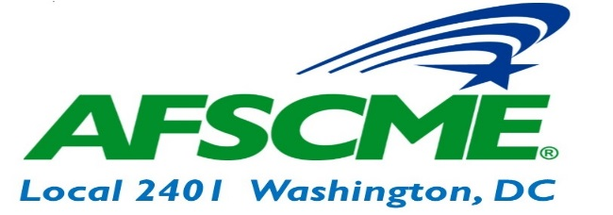
OFFICER |  | WORK # | UNION CELL #
President | Wayne Enoch | 202-724-7205 | 202-570-3136
Vice President | Paula Akinleye | 202-724-4805 | 202-365-7650
Secretary Treasurer | Dionne Duren | 202-724-3604 | 202-365-4504
Recording Secretary | Roger Scott | 202-727-3362 | 202-570-2948
Executive Board | Sabrina Brown | 202-724-2274 | 202-365-0127
 | LaShawna Lynch | 202-442-9833
 | Helen Shamwell | 202-442-8485
Trustees | Vernescher Brown | 202-724-8589
 | Carolyn Roberts | 202-535-1066
 | Moses Smith | 202-698-1886
 | Shop Stewards
FIRST NAME | LAST NAME | OFFICE | LOCATION | NUMBER(S) | EMAIL
Darnise | Henry-Bush | DDS | 250 E St. SE | 442-8432 | Darnice.bush@dc.gov
Ronald | Kenny | DDS | 1227 25th St. NW | 442-8526 | Ronald.e.kenny@ssa.gov
Helen | Shamwell | DDS | 250 E St. SE | 442-8485 | Helen.shamwell@dc.gov

Don’t forget to bookmark our website! Afscme2401.org
“AFSCME Local 2401”

