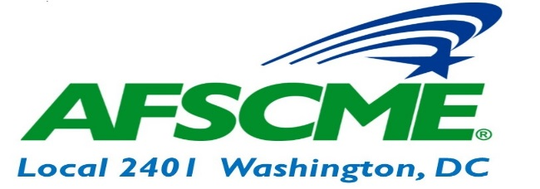
OFFICER |  | WORK # | UNION CELL #
President | Wayne Enoch | 202-724-7205 | 202-570-3136
Vice President | Paula Akinleye | 202-724-4805 | 202-365-7650
Secretary Treasurer | Dionne Duren | 202-724-3604 | 202-365-4504
Recording Secretary | Roger Scott | 202-727-3362 | 202-570-2948
Executive Board | Sabrina Brown | 202-724-2274 | 202-365-0127
 | LaShawna Lynch | 202-442-9833
 | Helen Shamwell | 202-442-8485
Trustees | Vernescher Brown | 202-724-8589
 | Carolyn Roberts | 202-535-1066
 | Moses Smith | 202-698-1886
 | Shop Stewards
FIRST NAME | LAST NAME | OFFICE | LOCATION | NUMBER(S) | EMAIL
Charles | Barbour | DHS | Taylor Street |  | charles.barbour@dc.gov
Lester | Cuffie | DHS | H Street |  | lester.cuffie@dc.gov
Nwakaego | Ekwuabu | DHS |  | 202-671-1080 | nwakaego.ekwuabu@dc.gov
Naomi | Eversley | DHS | Taylor Street |  | naomi.eversley@dc.gov
Constance | Freeman | DHS | Anacostia |  | constanceb.freeman@dc.gov
Cecilia | Holman | DHS | 920 Rhode Island Ave., NE | 202-727-8154 703-946-2830 | cecilia.holman@dc.gov
Danette | Johnson | DHS | H Street |  | dannette.johnson@dc.gov
Dorenda | Lewis | DHS | 64 NY Ave |  | dorenda.lewis@dc.gov
Charles | Parker | DHS | H Street | 645-4584 | Charles.Parker@dc.gov
Carolyn | Roberts | DHS | 64 NY Ave | 535-1066 | carolyn.roberts@dc.gov
Moses | Smith | DHS | 64 NY Ave | 698-1886 | mosessmith64@gmail.com
Felicia | Tyson | DHS | 2100 MLK | 360-3898 | felicia.tyson@dc.gov
Don’t forget to bookmark our website! Afscme2401.org
“AFSCME Local 2401”

