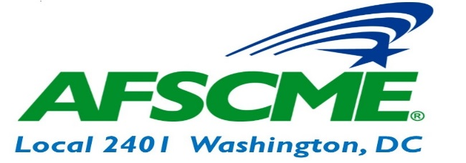
OFFICER |  | WORK # | UNION CELL #
President | Wayne Enoch | 202-724-7205 | 202-570-3136
Vice President | Paula Akinleye | 202-724-4805 | 202-365-7650
Secretary Treasurer | Dionne Duren | 202-724-3604 | 202-365-4504
Recording Secretary | Roger Scott | 202-727-3362 | 202-570-2948
Executive Board | Sabrina Brown | 202-724-2274 | 202-365-0127
 | LaShawna Lynch | 202-442-9833
 | Helen Shamwell | 202-442-8485
Trustees | Vernescher Brown | 202-724-8589
 | Carolyn Roberts | 202-535-1066
 | Moses Smith
 | Shop Stewards
FIRST NAME | LAST NAME | OFFICE | LOCATION | NUMBER(S) | EMAIL
Paula | Akinleye | OAG | 441-4th Street, NW |  | paula.akinleye@dc.gov
Sabrina | Brown | OAG | 441-4th Street, NW | 724-2274 | sabrina.brown@dc.gov
Dionne | Duren | OAG | 441-4th Street, NW |  | dionne.duren@dc.gov
Sheila | Jordan | OAG | 441-4th Street, NW | 821-6275 | sheilad.jordan@dc.gov
James | Lyles | OAG |  | 202-727-7125 | james.lyles@dc.gov
LaShawna | Lynch | OAG | 441-4th Street, NW | 442-9833 | lashawna.lynch@dc.gov
Latrice | Taylor | OAG | 441-4th Street, NW | 442-9856 | latrice.taylor@dc.gov
Rick | Helm | OAG | 441-4th Street, NW |  | rick.helm@dc.gov

Don’t forget to bookmark our website! Afscme2401.org
“AFSCME Local 2401”

